IDENTIFY CAR WASH SERVICES PROJECT

Software Requirements Specification

|  |  |  |  |
| --- | --- | --- | --- |
|  | Prepared By | Reviewed By | Approved By |
| Name | Pranav Patle | Venkataraman Chandrasekar |  |
| Role | CSD Interns | Batch Trainer |  |

**Table of Contents**

Table of Contents…………………………………………………………..….......II

1. Introduction…………………………………………………………………..…1

1.1 Intended Audience……………………………………………….......1

1.2 Project Scope…………………………...……………………………1

2. Overall Description…………………………………………….……………….1

2.1 Operating Environment……………………...……………………....1

3. Requirements……………………………………………………………...…….1

3.1Login………………………………………………………………….2

3.1.1Description………………………………………………....2

3.1.2 Functional Requirements……..…………………………...2

**1. Introduction**

This document outlines the requirements for testing the Doorstep Wash website. The tasks include capturing services details for “SUV” under “Car”, recording error messages during registration with invalid email, and retrieving center names for three different state-city combinations. The website for these tasks is DoorstepWash.

**1.1 Intended Audience**

Business Unit (BU) SME

Academy coach

Technical Trainer

**1.2 Project Scope**

This document defines at a functional level the business activities that are encompassed by the system and the rules that apply to them. It also encompasses some of the key high- and low-level technical requirements of the system.

It draws heavily on both proposed Framework and Business Rules and the Technical Architecture documents. The scope of the detailed analysis project phase specifies that this document will include.

· Classification of requirements according to their functional areas.

· A description of each process in the system, including their inputs, outputs, and data transformation rules.

**2. Overall Description**

**2.1 Operating Environment**

Windows operating system

Web application

**3. Requirements**

* + 1. Service Capture: Open DoorstepWash, select “Car” and “SUV”, click “Go for It”, and record all serviced names and amounts.
    2. Error Message Capture: Click “Register”, provide an invalid email, record the error message.
    3. Center Search: Navigate to “Our Centers”, select a state and city, and record the center name. Repeat with two more state-city combinations.

**3.1.1 Functional Requirements**

**3.1.1.1 Req0001**

**Req0001a-**The user selects “Car” from Select service type dropdown option.

**Req0001b**-The user selects "SUV” from Select Subcategory dropdown option.

**Req0001c-**The user clicks on “Go for it” button.

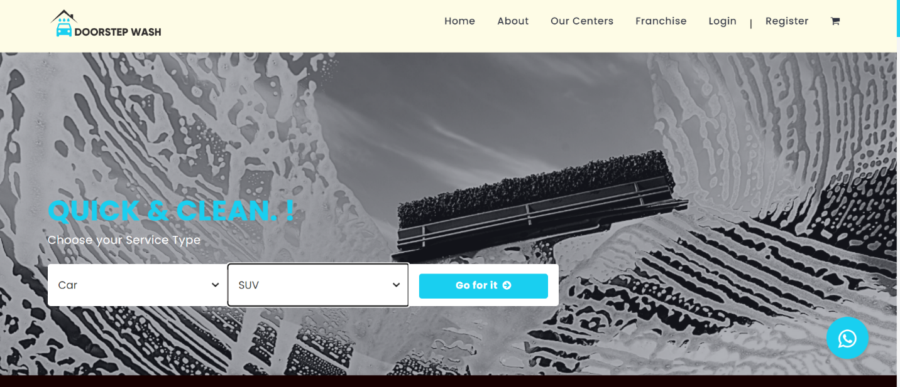

**3.1.1.2 Req0002**

**Req0002a**- The user clicks on “Register” button.

**Req0002b-** The user enters the name in the name field.

**Req0002c-** The user enters the email in the email field.

**Req0002d-** The user enters the password and confirm password in the password and confirm password field respectively.

**Req0002e-** The user clicks on sign up button and it will throw error upon entering invalid credentials.

**3.1.2.3 Req0003**

**Req0003a**-click on “Our Centers” on the navigation bar and scroll down to select state and city.

**Req0003b-** Select the state of your choice from the “Select your state” drop down menu.

**Req0003c-**Select the city of your choice from “Select your city” drop down menu.

**Req0003d-** Scroll down to look for the service center in that particular state-city combination.

